# **Section 11.2 Regular Expression Proofs**

## **Writing Convincing Proofs**

Problem: Prove that 5(2*x* + 4) + 20*x* = 8 + (5*x* = 2)6 given these axioms:

Distrib 1: a(b + c) = ab + ac; Distrib 2: (a + b)c = ac + bc and simple addition

How you would normally prove it (w/o the arrows):

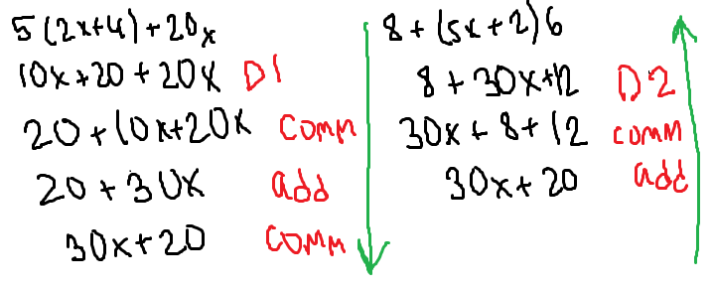

What you need to prove is deriving the second equation from the first, in the arrows’ order, rewriting it with proper justifications:

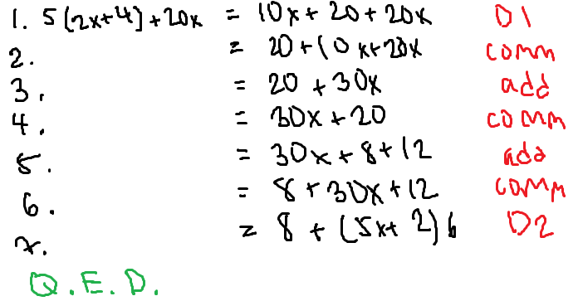

The proof is neat and tidy, every step is justified, the steps are numbered, and the QED ends it. The proof should make it look easy.

## **Regular Language Properties**

Properties found in Week 4 Handout, which is in the FoCS folder in Rowan 2020-2021 folder or on book page 744 (741 is also helpful for proving properties).

These properties help compare regular expressions for equality, and you can prove these properties using your knowledge of how sets work and the rules that tell you how to convert regular expression to a language and vice versa.

For example, prove that R + R = R.

Recall 2 regular expressions are equal if the languages that they represent are the same.

So, to prove, you need to prove that L(R + R) = L(R).

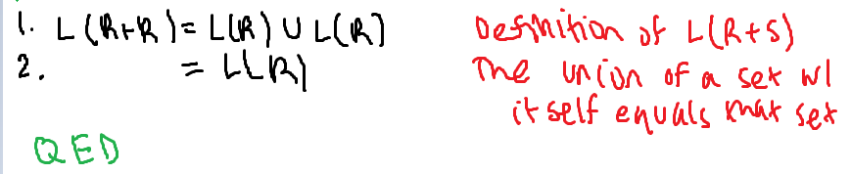

Prove that R • ∅ = ∅.

Goal: You need to show that L(R • ∅) = L(∅).

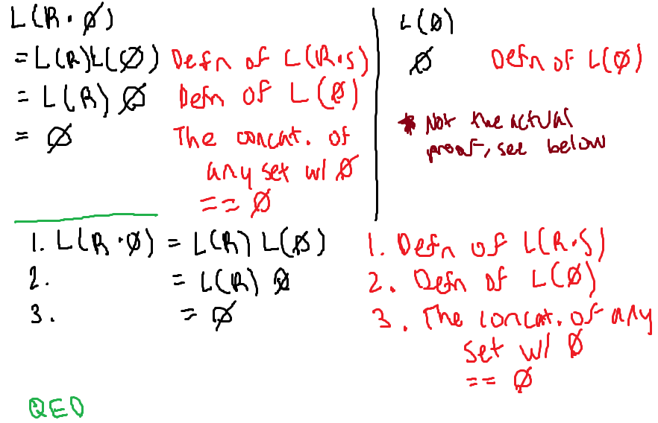

Let’s use these properties as axioms to simplify regular expressions and prove other things.

**Problem in the book #5: pg 747:** Simplify the following regular expressions and justify how you did so using the axioms: aa(b* + a) + a(ab* + aa)

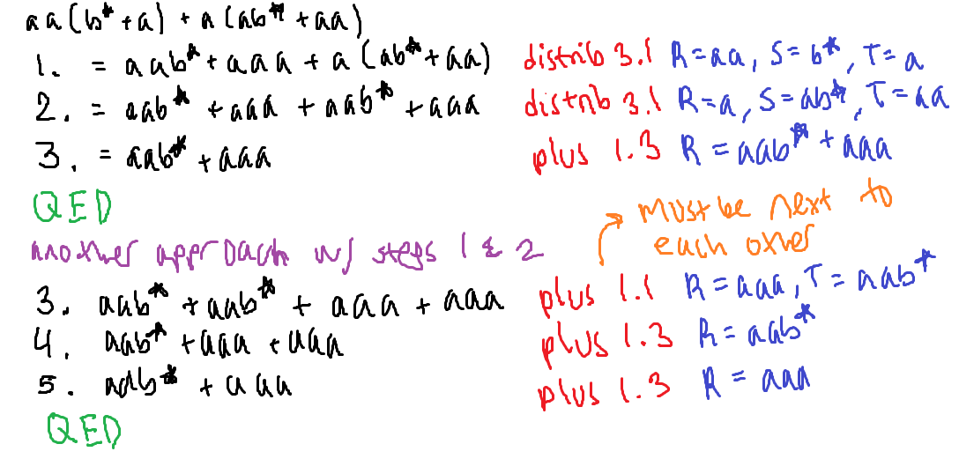

**Problem in the book #6a: pg 747:** Prove the following equality of regular expressions:

b + ab* + aa*b + aa*ab* = a*(b + ab*)

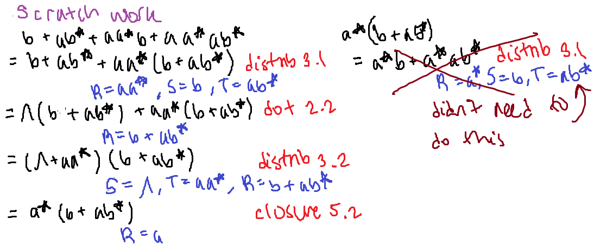

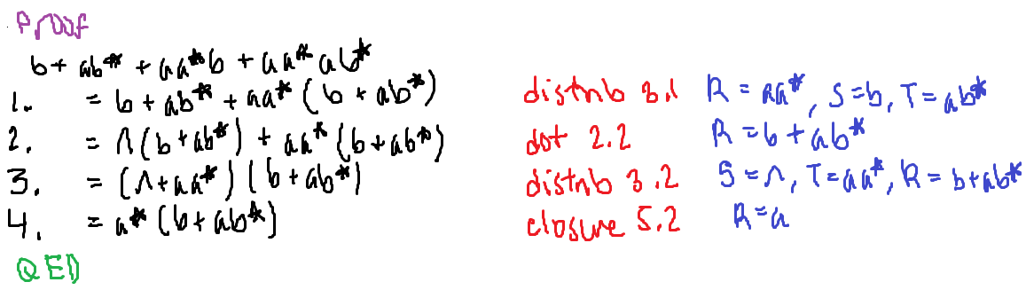

**Problem in the book: #6b: pg 747 (modified slightly):** Prove a*(b + ab*) = b + aa*b

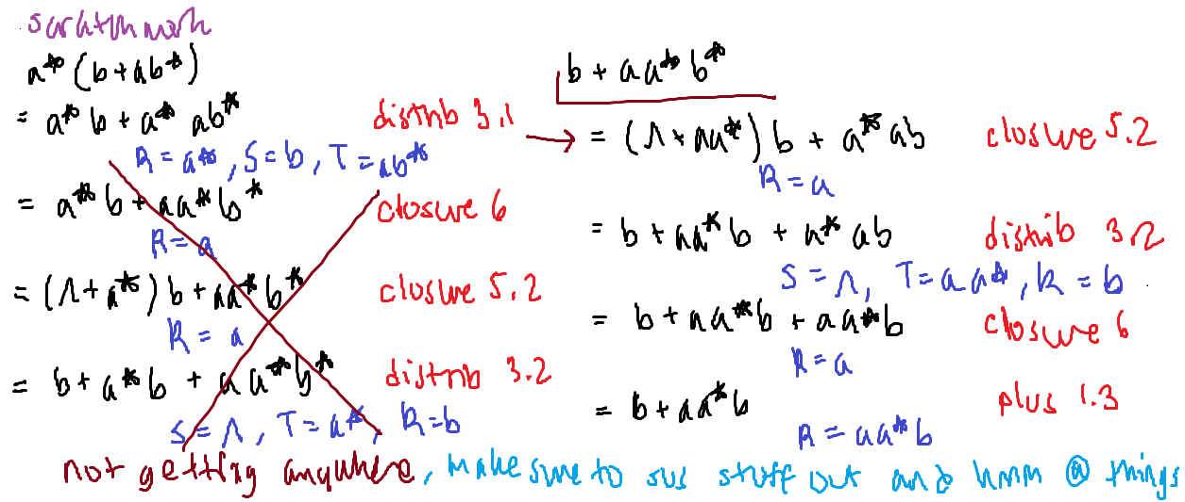

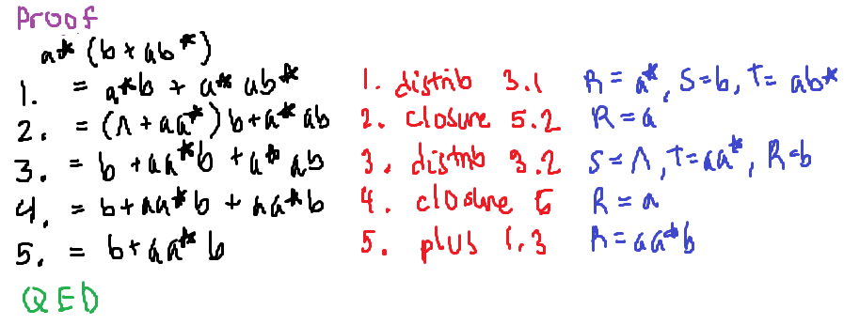

**Problem from the book #6c: pg 746:** Prove that ab*a(a + bb*a)*b = a(b + aa*b)*aa*b.

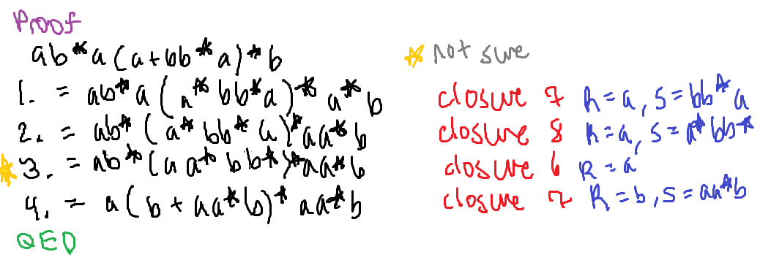

**Proof example (part of S20 midterm):** Prove that ab* + c(d + ee*) = a + ab* + ce*e + cd.

